Rio Rancho Club of New Mexico
“HAPPENINGS” October 18, 2016
All members please attend our Pints for Polio at Turtle Mountain Brewer (TBM)
Monday from 5:00 p.m. until 9:00 p.m. to support this cause and to help Earl make this another successful fund raiser. The donation fee is only $15.00 that includes a Rotary mug that will be refilled by TMB for only $3.00!
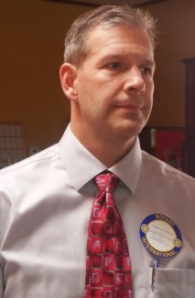
Jerry Reeder, our newest member, is replacing Sean as our Web Master. Sean has transferred to the Sunrise Rotary Club.
***************************************************************************
Roger Nagel was our Rotarian of the Day (ROD) and had an excellent presentation.
Photos by George Austin
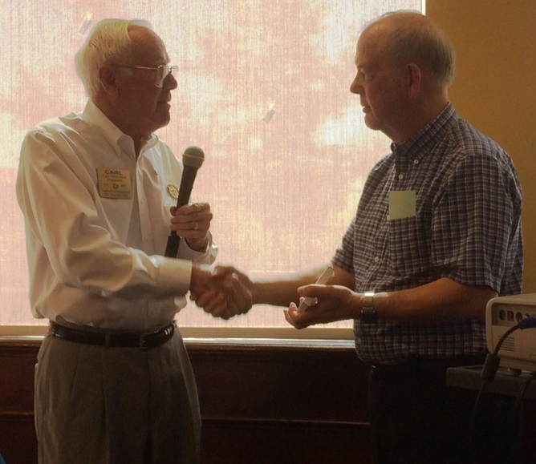
Carl thanks Dr. Bob Fugate for the very interesting program.
Roger provided this link for us to view https://breakthroughinitiatives.org/News/4
- Robert Fugate, Arctelum, LLC, New Mexico Tech
Dr. Fugate conducts a research program on atmospheric propagation physics, atmospheric compensation using laser guide star adaptive optics. Dr. Fugate’s research program also includes the development of sensors, instrumentation and mount control of large-aperture, ground-based telescopes.

Internet Investor and Science Philanthropist Yuri Milner & Physicist Stephen Hawking Announce Breakthrough Starshot Project to Develop 100 Million Mile per Hour Mission to the Stars within a Generation
$100 million research and engineering program will seek proof of concept for using light beam to propel gram-scale ‘nanocraft’ to 20 percent of light speed. A possible fly-by mission could reach Alpha Centauri within about 20 years of its launch.

